30.44: a) 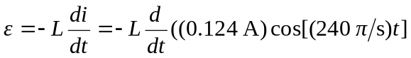

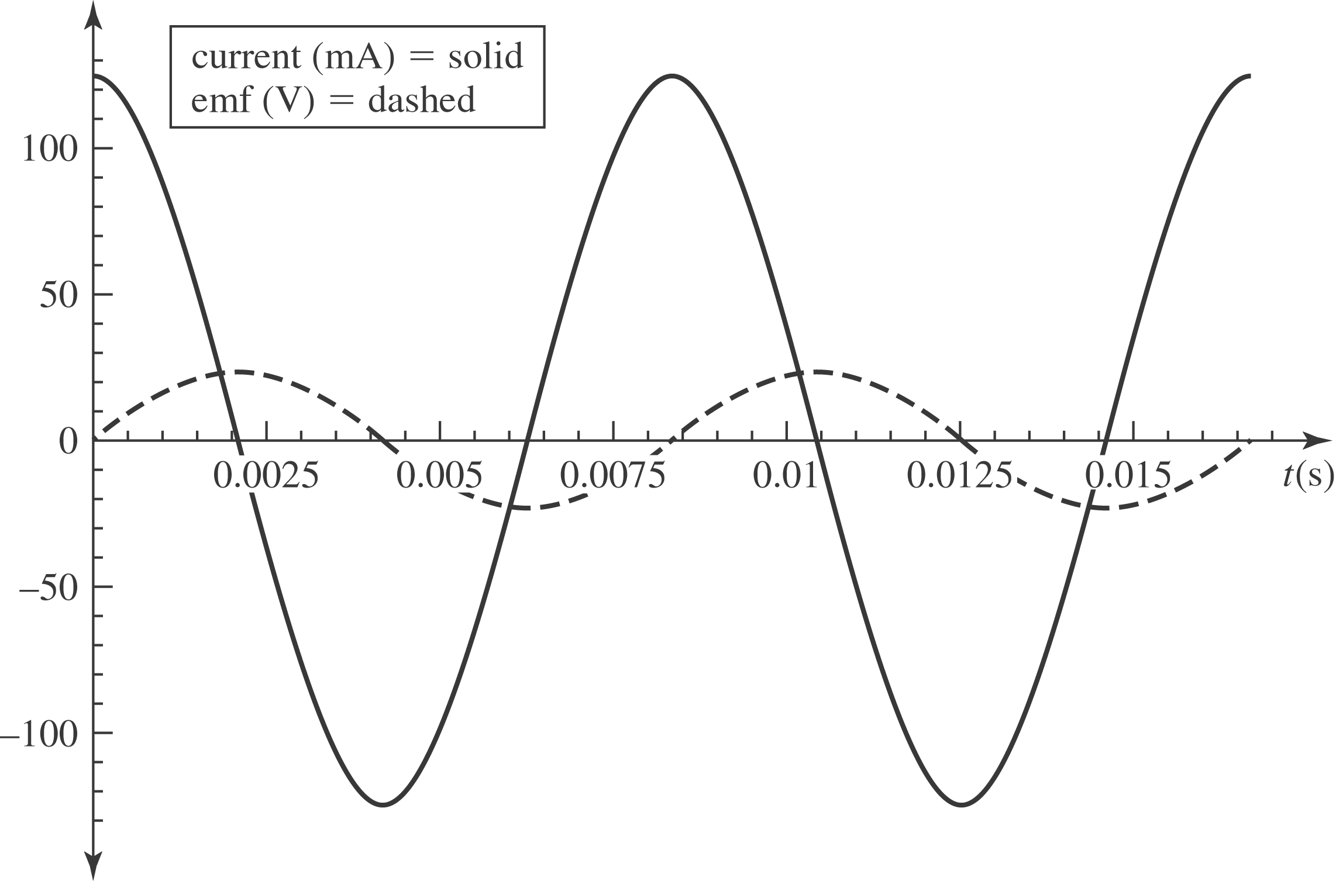

b) 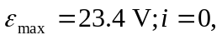since the emf and current are 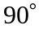out of phase.
c) 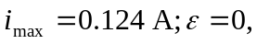since the emf and current are out of phase.

